**FINA 375: Business Analytics**

**Assignment 2 Visualization and Data Summary**

**Name/Team: Romario Medel-Estrada**

**Table 1: Summary or Descriptive Statistics**

**Sate: New York**



One of the most notable values is a wage income mean of around $48,977 along with the average age being 43.2 years old. I guess one could conclude that the average 43-year-old in New York makes about $48,977 in yearly income with about $520 in other income. The mode for age is 62 which means that there are mode 62 year olds in New York than any other age in the workforce. In Minnesota the average wage income comes in slightly less at $45,684 and the average age of employment is about 44 years old. Almost equal to New York. The mode of employment age is 61 years of age, again very similar. The range in wage income is the biggest difference, with New York being $761,000 and Minnesota being $578,000.

**Figure 1. Histogram of Wage Income**

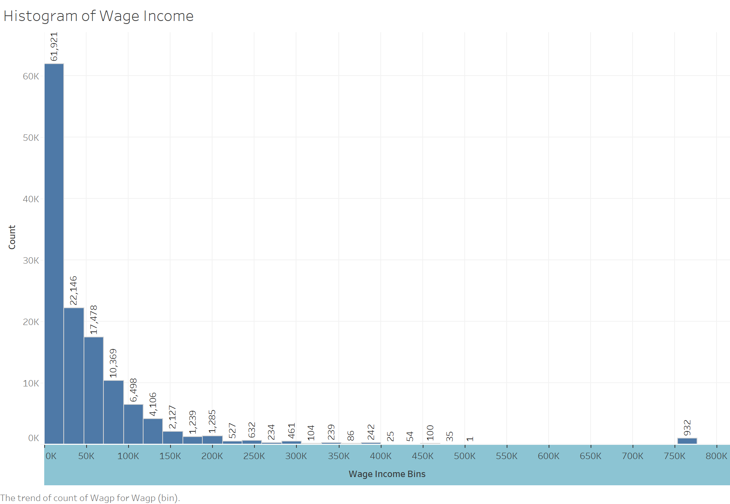

Most notably, 61,921 people fall into the wage bin of 0-$25K. That is almost triple the number of individuals in the next wage bin, 22,146 people earning between $25k-$50k. Of course, this does not show us how many earn anywhere from $20k-$30K; so we can get a wrong impression from this data as the wage bin intervals are somewhat large. What we can see is that as the wage bins increase, the number of earners decreases almost inversely. An exponential decay formula could be used to describe the rate at which the number of earners decreases as the wage bins go up. This model of prediction would fall apart when we get to earners in the wage bin $750k-$775K where there are 932. Compared to the Minnesota bar chart, the curve is very similar. Except, Minnesota appears to have more earners in their third wage bin (40k-50k), but we cannot compare directly to New York as the wage bins are structured differently, what we can see is that most of the earners are in the lowest wage bin just like New York. With the number of earners exponentially decreasing as the wage bins increase.

**Figure 2: Bar Chart of Average Wage Income by Employment Status**

We can see that public employees tend to do better than private employees; they both earn more on average than self employed individuals. Again, the same is true for Minnesota; the only difference is how much they are earning, in every category New York average wages are higher. But the difference between average wages in Minnesota of public vs private employees is only a difference of around $3,000. Where the difference between average wages in New York of public vs private employees is around $9,000. We can say that on average the difference between average wages of public vs private employees is 3 times more in New York than in Minnesota. Self-employed average wage is virtually the same.

**Figure 3: Scatter Plot of Age on Wage Income**

Across all ages there seems to be a higher concentration of individuals that make less than $100,000 in New York. We can confidently say that regardless of age, most people in New York tend to earn less than $100,000. Again, the graphs between New York and Minnesota look similar. In both graphs there are very small concentrations of high earners across the age categories. The New York graph ascends in earned income as age increases, telling us that it is more likely for earnings to grow as we age. Same goes for the Minnesota graph, they both plateau from 30 years of age forward.

**Figure 4: Heat Map of Proportion Disabled by Age Categories**

We can clearly see that most disabled individuals that are privately employed are older in age (56-67). The same can be said for Minnesota as the heat maps look almost identical. The least amount of disabled employed individuals comes from the age group of 18-25 which is expected to say the least. The same can be said for the state of Minnesota.

**Pivot Tables**

**Table 2: Count of Disabled Individuals by Age Categories**



In the state of New York, we can clearly see that when we look towards the older age groups, the number of disabled individuals increases. The same can be said for Minnesota. There are most disabled people in New York than in Minnesota because of population but, in proportion they are very equal. Minnesota has a total of around 11.46% disabled employed individuals surveyed vs New York’s 11.70%.

**Table 3: Average Age by Employment Status and Educational Attainment Level**



The average age of employment for a master’s degree or higher is 45 years of age. This is very close to the average age of high school or less level of schooling at 44 years of age. In Minnesota the age of employment is slightly higher across the board. We cannot say that the level of education is a clear indicator of average age of employment in either state.

**Table 4: Average Income by Employment Status and Educational Attainment Level**



Higher educated individuals earn more than lower educated individuals on average. We can see that in the private sector the next level of education guarantees you a little more than double the average wages that the previous level of education BOTH in New York and Minnesota. We do not see the same trend in the public sector for either state, which is very fascinating.

**Table 5: Percentage of Disabled individuals by Sex and Age Categories**



Females are slightly more disabled across all age groups than males. But the difference is less than 1% in any given age group with the ages of 18 to 25 being the closest, and ages of 56 to 67 being the widest range (still less than 1%). We can say that the effect of gender on disability is negligible in New York. In Minnesota, it is the opposite, where males are slightly more disabled than females. Overall, there is a higher than 1% difference.